**Neighborhood Segmentation in Cambridge MA**

Michael McCormick

May 19th, 2019

1. **Introduction**
   1. **Background**

Cambridge Massachusetts is the 5th most populous city in the state and is part of the Boston Metropolitan area. As a resident and employee within the city, I decided to look at Cambridge for this project. Cambridge has been called the "City of Squares", as most of its commercial districts are major street intersections known as squares. Each square is a neighborhood center. Including the 6 main squares, there are a total of 13 neighborhoods within Cambridge. As of the census of 2010, there were 105,162 people, 44,032 households, and 17,420 families residing in the city. The population density was 16,354.9 people per square mile (6,314.6/km²). There were 47,291 housing units at an average density of 7,354.7 per square mile (2,840.3/km²)

* 1. **Problem**

Based on the commercial districts and population figures, there is a relatively high level of density of people and housing. This would have a tendency to lead owners of shops and social sharing places in the city where the population is most dense and less competition. When we think of it by the investor, we expect from them to prefer the districts where the type of business they want to install is less intense. At the same time, they may want to choose an area that has high social activity and pedestrian foot traffic. However, it is difficult to obtain all of this information readily for the average investor or business owner.

* 1. **Interest**

The density of business by like neighborhoods would be of interest to business developers, investors, and small business owners. It would also be optional data for families and homebuyers that are looking for a particular set of venues to be within their neighborhood or walking distance.

1. **Data and Sourcing**

In consideration of the problem noted above, the following data has been collected:

* Neighborhood mapping based on the Community Development Department of the city of Cambridge:

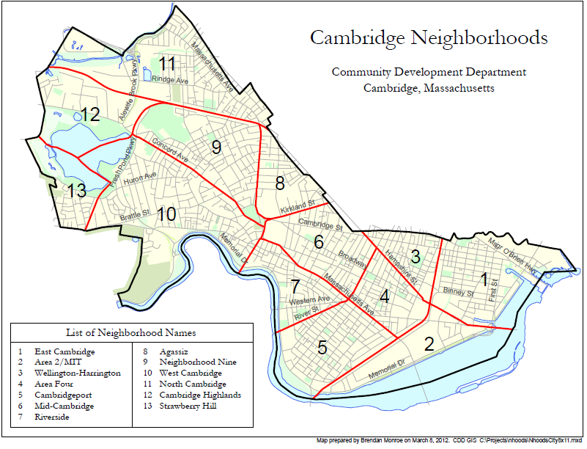 - <http://www.cambridgema.gov/~/media/Files/CDD/Maps/Neighborhood/cddmap_nhood_index.ashx>

* Using neighborhood names above, Google map search function was used to gather the center coordinates for each neighborhood.
* Combining the neighborhoods and Longitude and latitude into one data set, a .json file for all of Cambridge was produced.
* Combining this data with the Forsquare API to get the most common venues and attractions within each neighborhood

1. **Methodology**

**3.1 Preparation and exploratory analysis**

Combining the neighborhood mapping and Google provided coordinates, a data frame was constructed to include all initial data points:

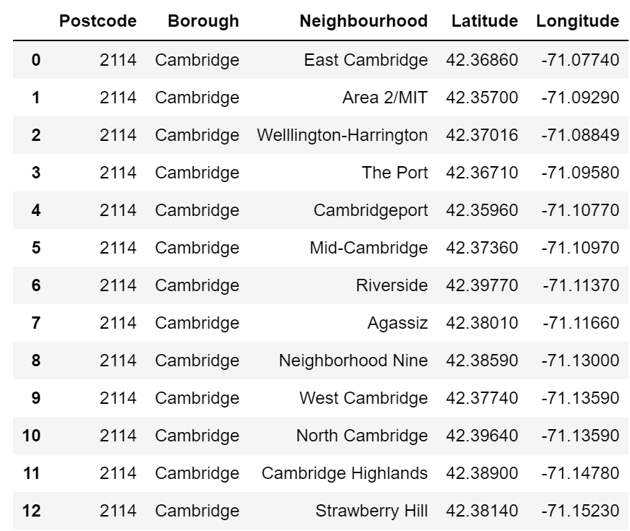

Using the Geolocator function, the coordinates for Cambridge MA was determined to be 42.375 latitude and -71.105 longitude.

Installing and running the python folium library and the above latitude and longitude coordinates, an initial map of Cambridge was constructed:

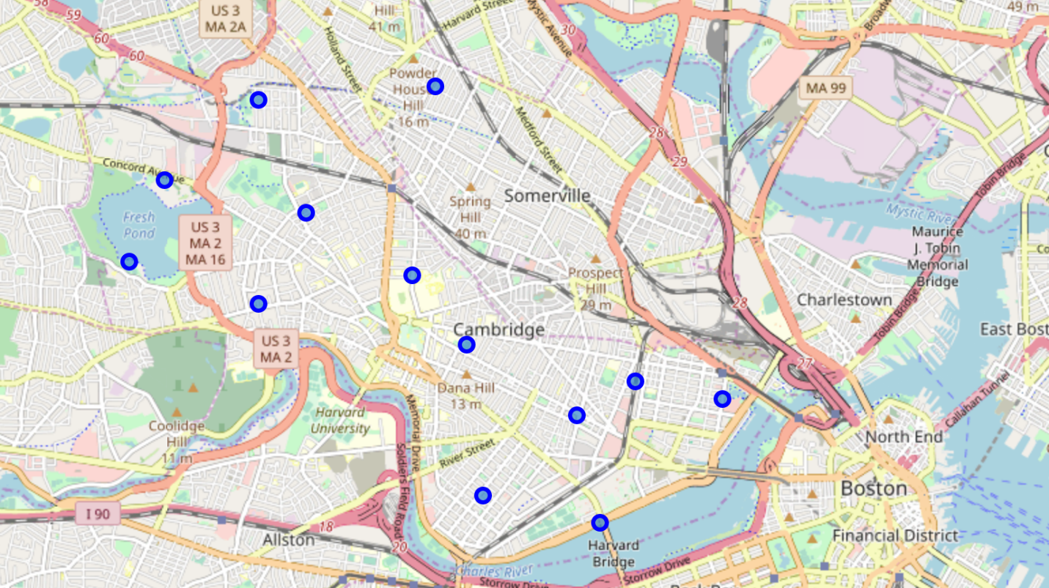

Based on the coordinates for each neighborhood, the Foursquare API was utilized to explore venues within each neighborhood and segment them. The data has a limit of 100 and a radius of 500 meters. A total of 337 venues were returned. Here is a summary list based on the first rows of data:

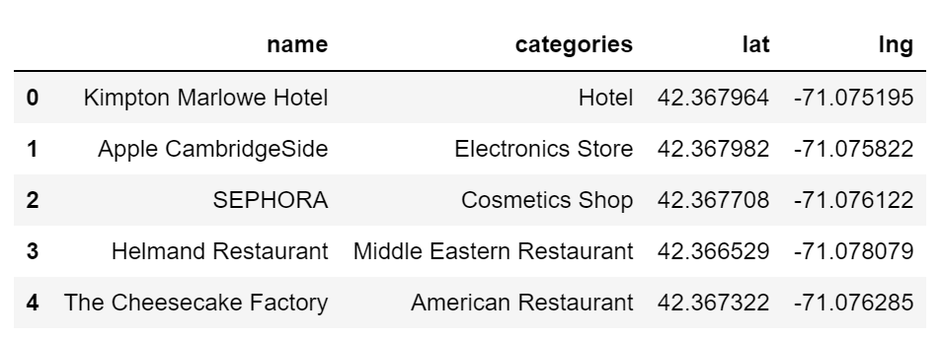

No neighborhood broke the 100 limit as the highest returned venues were for East Cambridge and the Port at 48 and 46 respective. Strawberry Hill had the smallest number of venues at 5. The results do not include every possible venue as the data is determined by initial latitude and longitude designation and parameter limits of total and distance. Increasing any of these factors would increase the possible number of returned venues.

Here is a summary breakdown of each neighborhood with their total number of venues returned as well as the data frame table with the merged data:

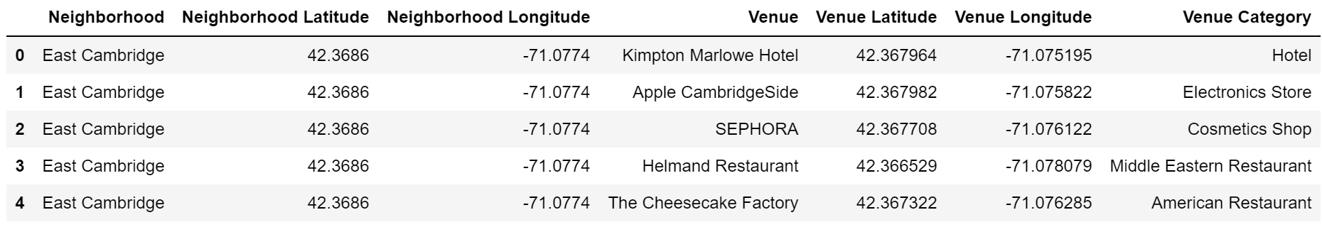

Based on the 337 total returned values, the data was narrowed down to the top 15 venues per neighborhood. The summary table is below:

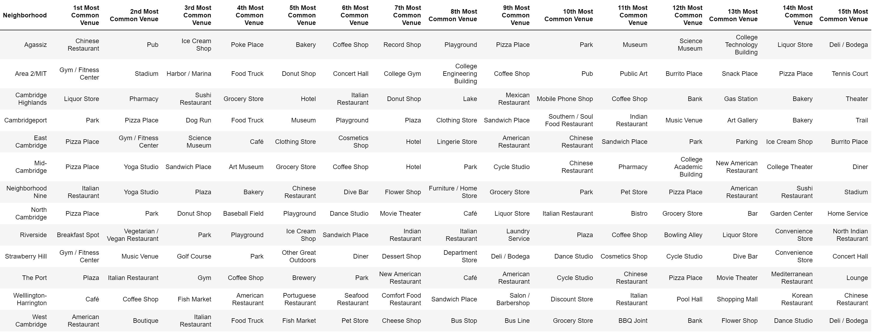

**3.2 Machine Learning test**

Based on the returned and merged data set, several neighborhoods share similar venues, especially in the first most common venue. Using the unsupervised learning K-means algorithm, the neighborhoods will be clustered together based on the venues returned. K-means algorithm is one of the more common clustering methods that exists within unsupervised learning.

The K-means was run using a cluster set of 5 based on the neighborhoods and assumed number of clusters. The number of clusters would be changed based on the K-means elbow method to ensure optimum K of the K-means but for testing purposes the cluster set was left at 5.

**4. Results**

Based on the K-means algorithm and cluster setting of 5, here is the merged output of cluster segmentation with neighborhood and venue data:

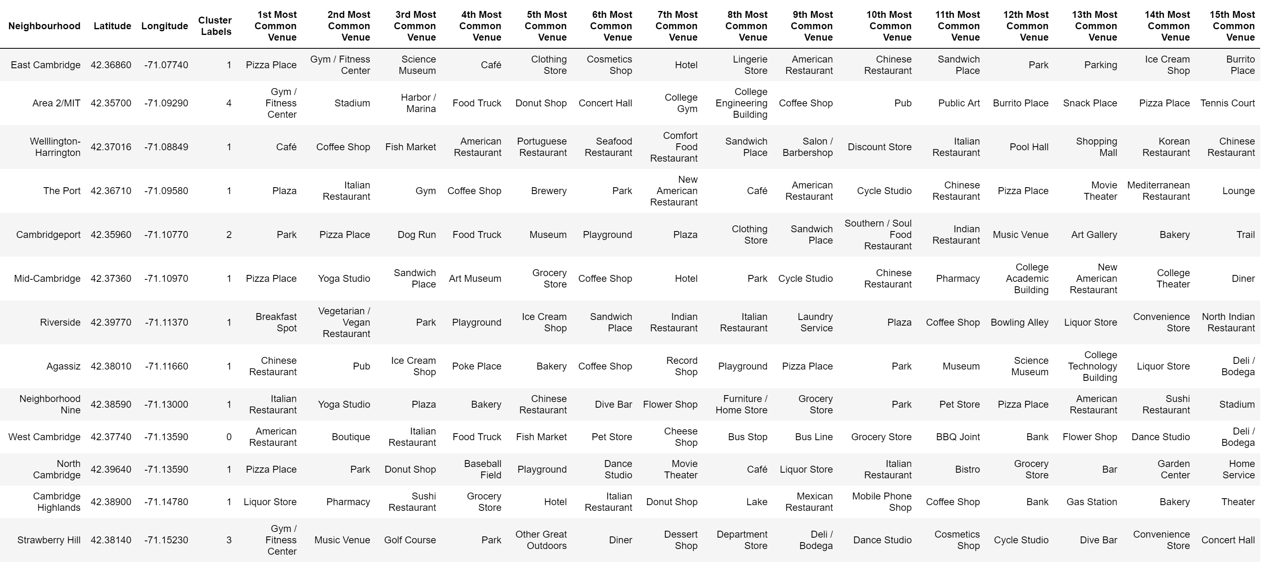

Again, using the python folium package, a visual map was created that shows the individual clusters:

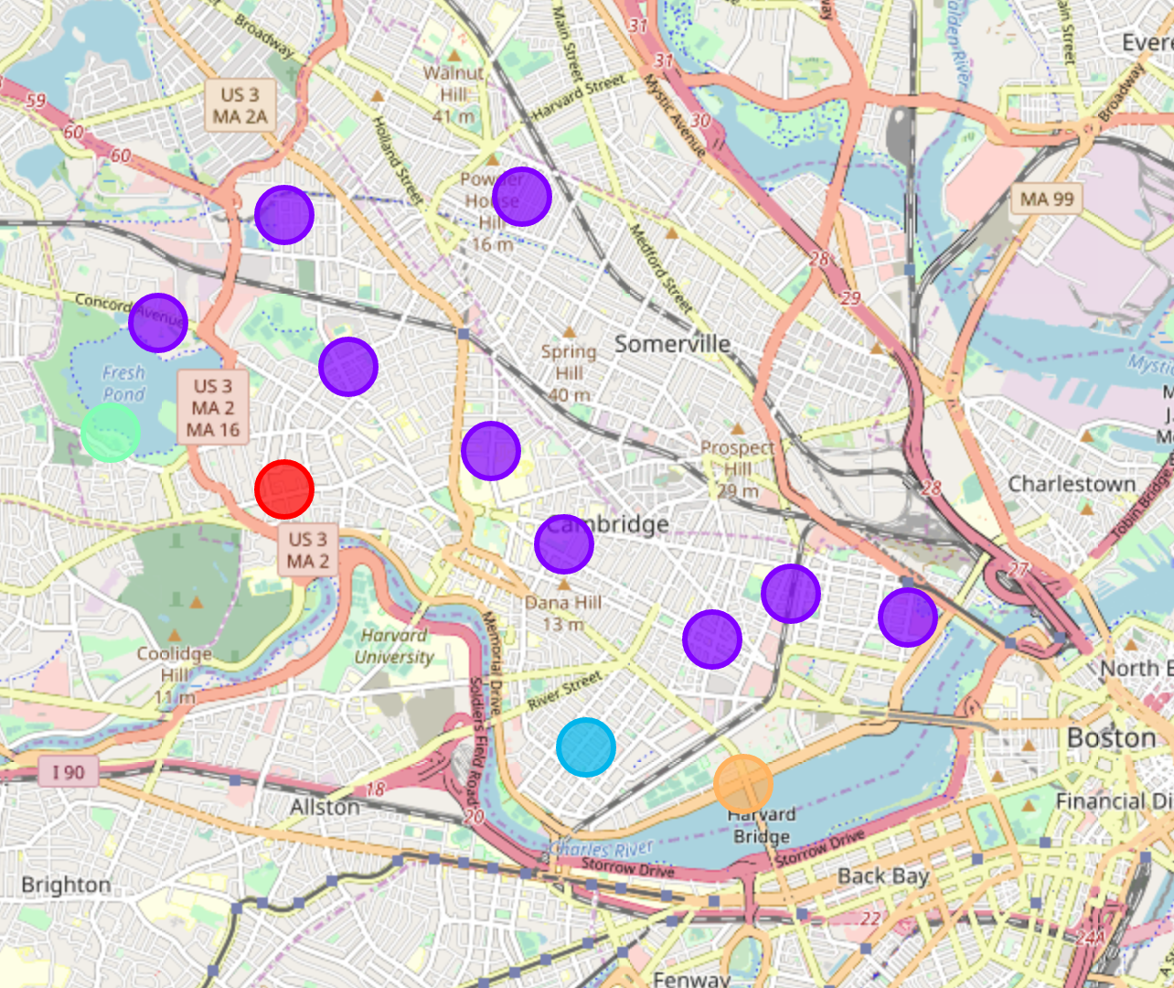

Here is the breakdown of each cluster and their associated top venues:

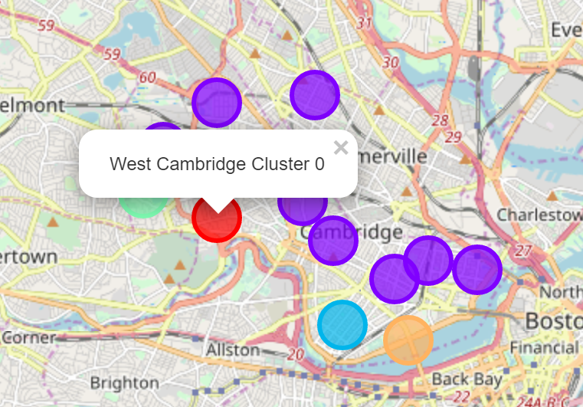



West Cambridge observations: while 2 out of 3 top venues are restaurants, most common venues are stores so area has more commercial appeal in small stores or services. This would be used by investors or small business owners who are looking for investment opportunities or opening up new stores as it appears to be a popular store front area.

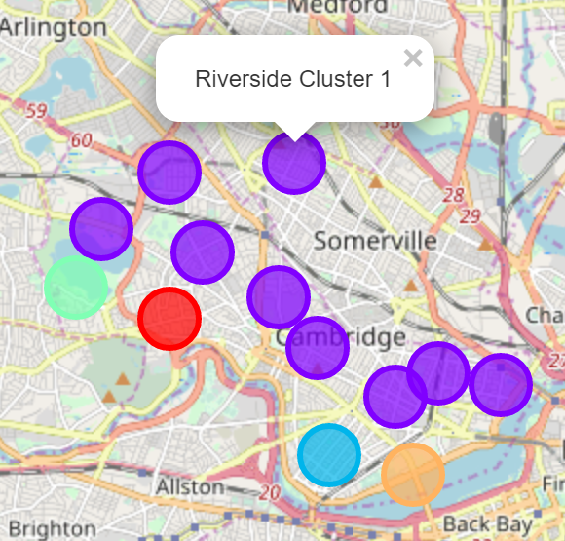

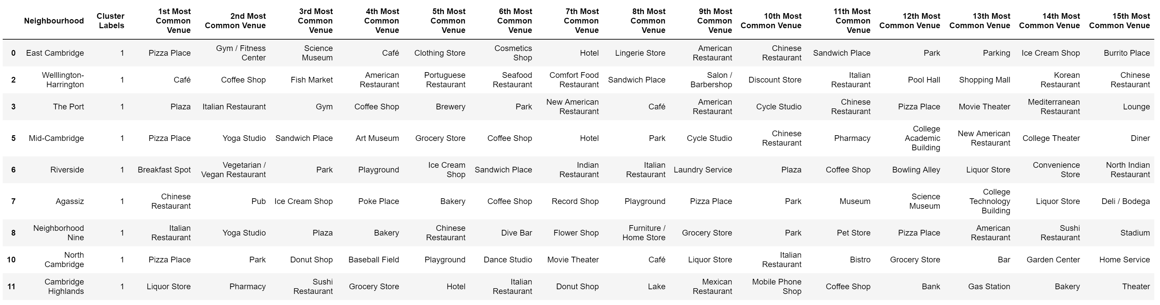

Cluster 1 Observations: Dominate cluster of all segments as it encompasses 9 out of 13 neighborhoods, a 69% concentration of neighborhoods. Most common venue is restaurants, particularly Pizza places. The second most common venue across the cluster is parks so a good amount of outdoor area. This would be important to individuals looking to move into the area that enjoy outdoors. Cafes and bakeries are also popular which would be of interest to investors and small business owners as it might have over saturation of this type of venue.

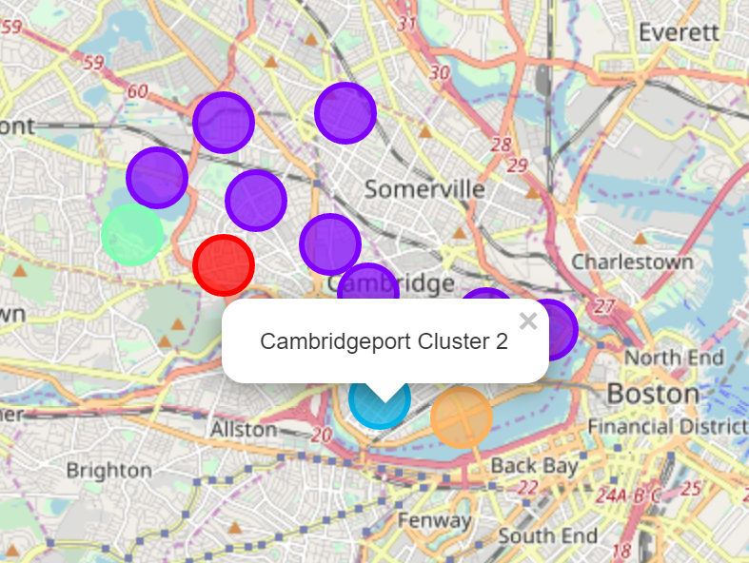



Cambridgeport cluster Observation: Highest venues are parks and dog run so outdoor space for potential renters or homebuyers in the area. Pizza place is the second venue and a few other restaurant or food service venues. Potential for investors or small business owners looking to open a new food related venue as there appears to not be an over saturation of this type.

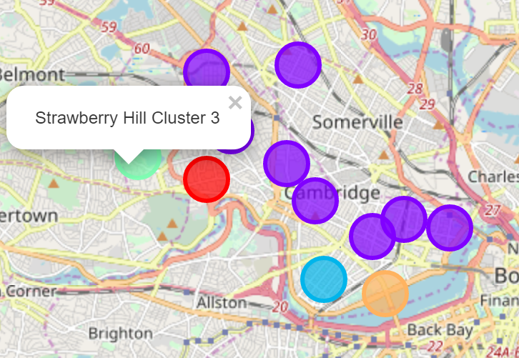



Strawberry Hill cluster observation: The lowest venues for all neighborhoods. As it appears to be on the outskirts of Cambridge the most common venues are related to outdoor and physical activities. There is a lower amount of restaurants or service venues so population might not demand them. Would be more attractive to individuals who lead an outdoor, active lifestyle.

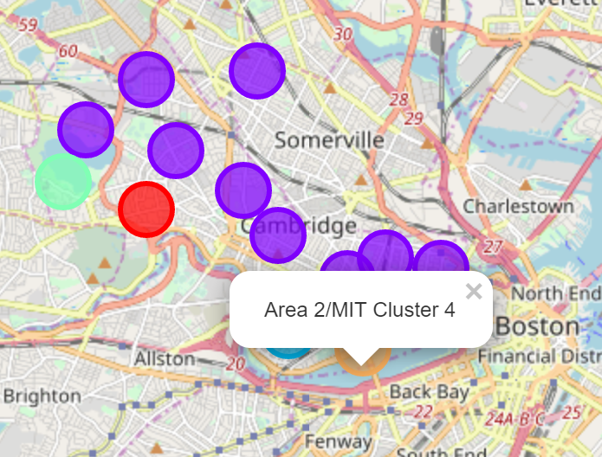



Area 2/MIT cluster Observations: Area is dominated by MIT college so most venues are related to the school or student life. Potential investment opportunity with the school or small business that caters to college students.

**4. Discussion and Conclusion**

**4.1 Discussion**

As mentioned, Cambridge MA is the 5th most populous city in Massachusetts and is continuing to grow. As the neighborhoods continue to grow and evolve different levels of complexity emerge and therefor very different approaches can be attempted via clustering and classification studies. Although each classification model can yield different results, each one will slightly vary in quality. Using the K-means algorithm and a cluster set at 5, 69% of neighborhoods fell into the same cluster. For more detailed and accurate model, the data can be expanded and the details of each neighborhood can be analyzed further.

**4.2 Conclusion**

Although the data set and clustering would be enough for most investors or individuals looking for an area to live in, to improve the analysis more data would be required. The coordinates of each neighborhood could be focused more to the individual areas or blocks in order to change the level of venue clustering. Based on the clustering visualization, future studies can included population densities, average sales price of products, median income, or tax detail to help further distinguish the data set. This improved analysis could not only just be used by investors but city planning or other government entities.